

**EDGE CSE CUET DIGITAL SKILLS TRAINING**

Project Report on

**Development of a Digital Marketing Strategy for a “Ladies Bag” Store**

**Batch Name: CBF-023 Digital Marketing**

This Project report (CBF-023 Digital Marketing) is submitted to the Department of CSE, Chittagong University of Engineering and Technology (CUET) to fulfill the partial requirement of the Degree of Digital Marketing Course.

**Submitted by:**

**Name:** Subvro Mollick Sani

**Batch:** CBF-023 Digital Marketing

**Supervised by:**

Shaikat Sharma

Trainer, EDGE-CSE-CUET

October 2024

**Title**

**Development of a Digital Marketing Strategy for a “Ladies Bag” Store**

**Abstract**

In today's competitive landscape, a well-defined digital marketing strategy is essential for startups seeking to establish their brand and attract customers. This paper outlines the key components of developing an effective digital marketing strategy tailored for startups. It begins with an analysis of the target market and competitive landscape, emphasizing the importance of understanding customer personas and behavior. The strategy includes the selection of appropriate digital channels—such as social media, search engine optimization (SEO), content marketing, and email marketing—to optimize reach and engagement.

**Introduction**

In an increasingly digital world, startups face unique challenges and opportunities when establishing their presence in the market. The rapid pace of technological advancement and shifting consumer behaviors demand that new businesses adopt effective digital marketing strategies to differentiate themselves and connect with their target audience. Unlike established companies, startups often operate with limited budgets and resources, making it crucial to implement a strategic approach that maximizes impact.

A robust digital marketing strategy serves as a roadmap for startups, guiding them through the complexities of online marketing channels while aligning their efforts with business goals. This introduction outlines the fundamental aspects of crafting such a strategy, beginning with the identification of target audiences and the competitive landscape. By understanding customer personas and their preferences, startups can tailor their messaging and choose the most effective platforms for engagement.

Additionally, the introduction addresses the significance of setting measurable objectives and key performance indicators (KPIs) to track success and adapt strategies accordingly. As startups navigate this dynamic environment, the ability to pivot based on data-driven insights will be vital for sustained growth and brand loyalty. Overall, this discussion aims to provide a comprehensive framework for startups to harness the power of digital marketing, ensuring they can effectively compete and thrive in the marketplace.

Methodology

The development of a digital marketing strategy for a startup involves a systematic and structured approach to ensure all elements are effectively integrated and aligned with the business objectives. This methodology can be broken down into several key phases:

1. **Market Research and Analysis**:
   * Conduct qualitative and quantitative research to understand the target market, including demographics, psychographics, and purchasing behavior.
   * Analyze competitors to identify their strengths, weaknesses, and strategies, providing insights into market positioning.
2. **Defining Target Personas**:
   * Develop detailed customer personas based on the research findings. These personas should encompass key characteristics, pain points, motivations, and preferred communication channels.
   * Utilize surveys, interviews, and social media analytics to gather insights directly from potential customers.
3. **Setting Objectives and KPIs**:
   * Establish clear, measurable goals that align with overall business objectives, such as brand awareness, lead generation, or sales conversions.
   * Define key performance indicators (KPIs) to assess the effectiveness of the digital marketing efforts, including metrics like website traffic, engagement rates, and conversion rates.
4. **Channel Selection and Strategy Development**:
   * Evaluate various digital marketing channels (e.g., social media, SEO, content marketing, email marketing, PPC) to determine the most effective avenues for reaching the target audience.
   * Create a comprehensive strategy for each selected channel, outlining specific tactics, content types, and timelines.
5. **Budgeting and Resource Allocation**:
   * Develop a budget that allocates resources to each channel based on expected ROI and available financial resources.

Consider leveraging cost-effective tools and platforms that cater specifically to startups.

1. **Implementation Plan**:
   * Create a detailed action plan that includes timelines, responsibilities, and milestones for each component of the strategy.
   * Ensure cross-functional collaboration among team members to facilitate smooth execution.
2. **Monitoring and Optimization**:
   * Implement tracking mechanisms to monitor performance against the established KPIs.
   * Regularly review data and analytics to identify trends and areas for improvement, allowing for real-time adjustments to the strategy.
3. **Feedback Loop**:
   * Establish a continuous feedback loop with customers to gather insights and refine marketing efforts based on their responses and behaviors.
   * Encourage engagement through surveys and social media interactions to foster community and loyalty.

By following this structured methodology, startups can create a dynamic digital marketing strategy that not only enhances visibility and engagement but also adapts to the ever-changing digital landscape, driving long-term success

Bottom of Form

**Result**

**The next steps of the work are shown with the help of pictures.**

### Facebook

**Creating Facebook page:**

**Fig :1**

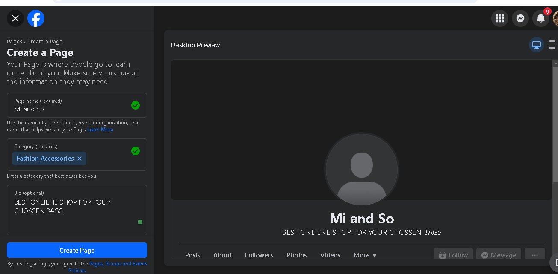

Name

Category

Bio

**Uploading logo & Cover:**

**Fig: 2**

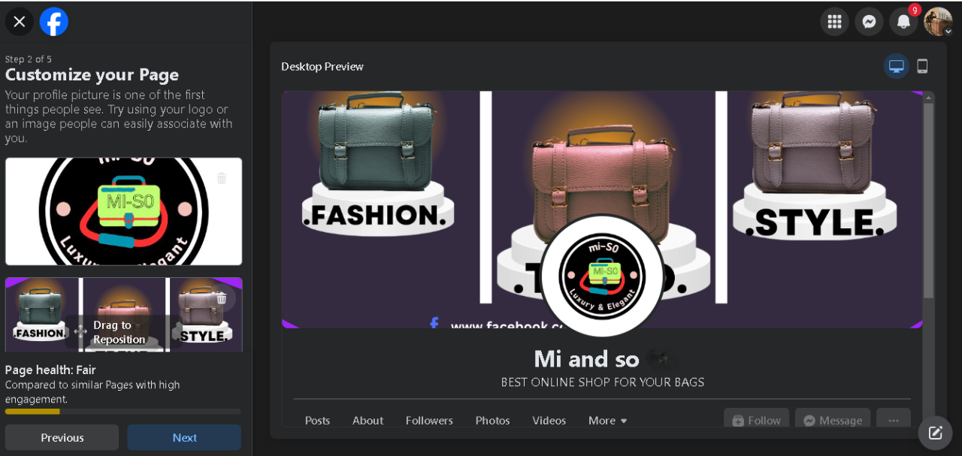

Cover

Logo

**Creating Reel:**

**Fig: 3**

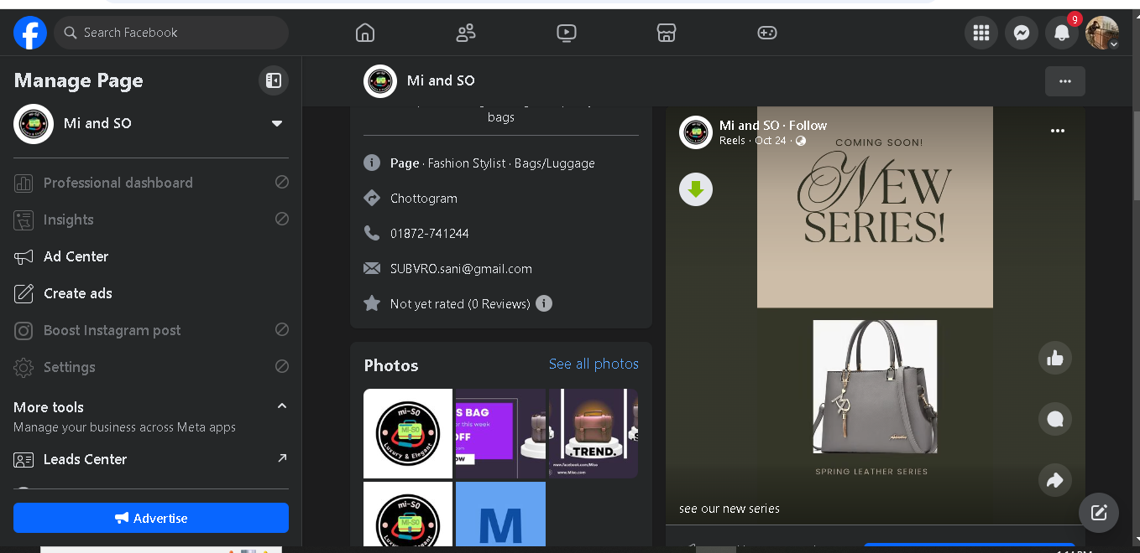

Reel Video

**AD Creation:**

**Fig: 4**

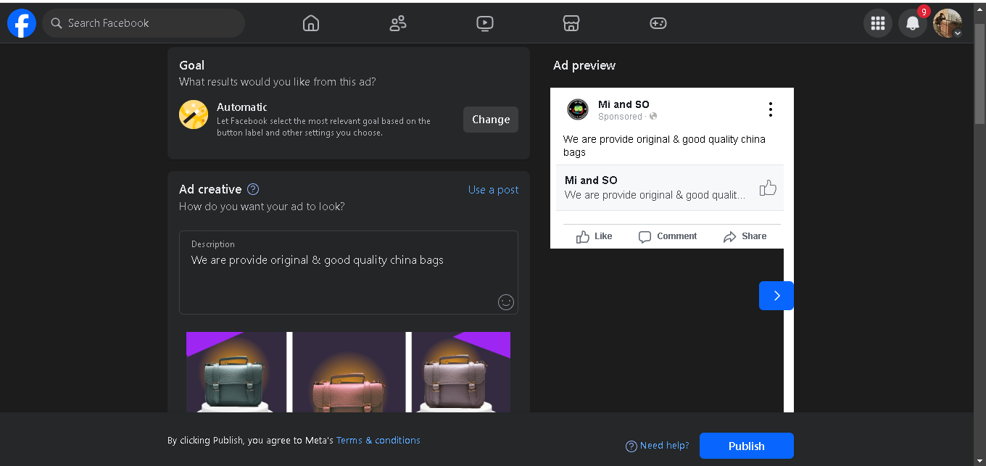

Website

**Web – Site**

**Creating a website by using tool (PENTHION.IO)**

Fig :1

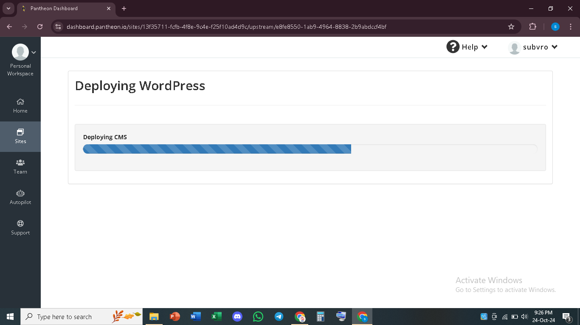

**Deploying website throw the CMS**

### Log in Dashboard:

### Fig: 2

### 

### Adding Plugin: payment Method (Bkash, Nagad, Roket)

### Fig: 3

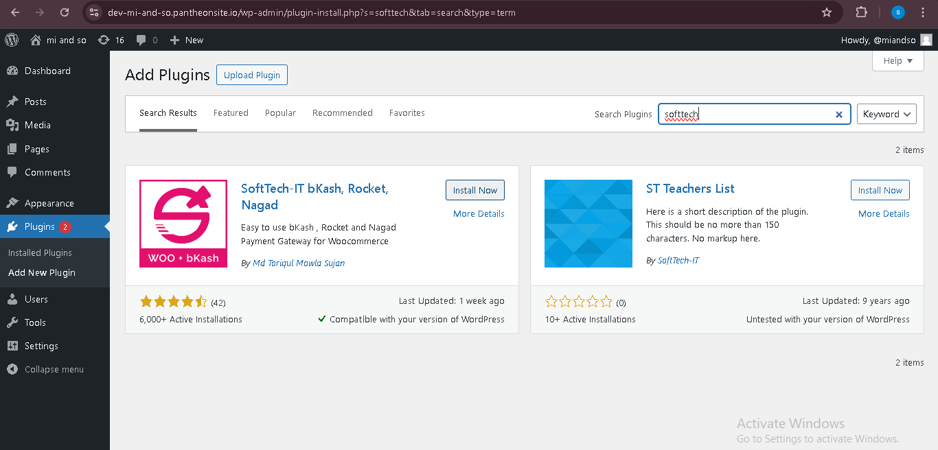

Mobile Banking Payment Method

### SEO

### *Key word Research*: Using Tool’s “Magools”

### Fig: 1

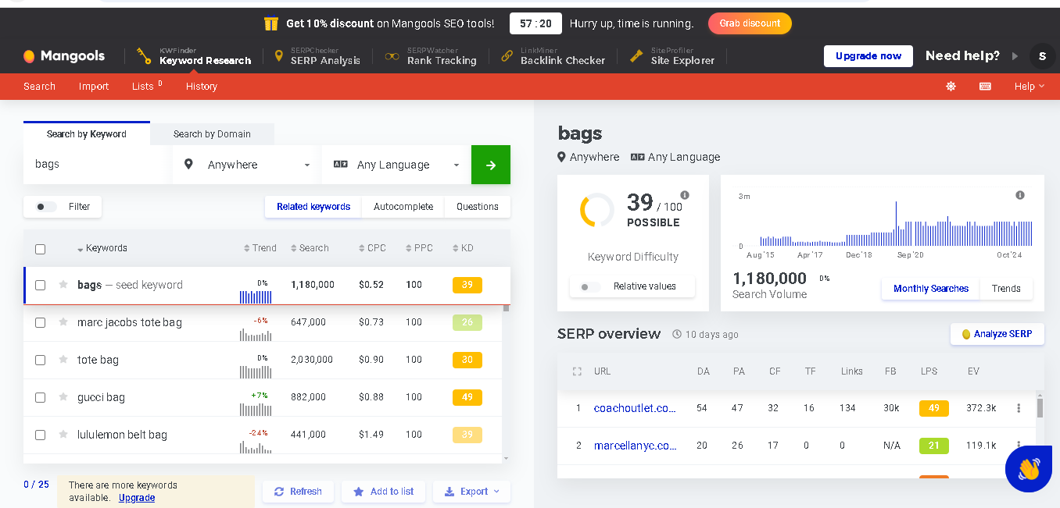

keyword

Analytics

### Fig: 2

### 

When use Specific Keyword, then result is deferent

### Email Marketing

**Using tool**: “Kit” (Old canverkit)

### Fig: 1

### 

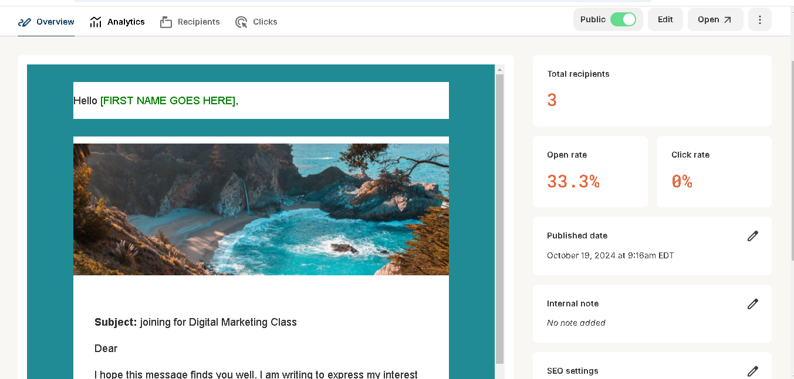

**Fig: 2**

Auto Customer name are selected

### Conclusion

In conclusion, a well-crafted digital marketing strategy is vital for startups to effectively establish their brand and engage their target audience. By conducting thorough market research, defining clear objectives, and continuously optimizing efforts based on data-driven insights, startups can navigate the digital landscape successfully and achieve sustainable growth.

### *References*

### Shaikat Sharma, Digital Marketing Trainer

1. Kotler, P., & Keller, K. L. (2020). Marketing Management (15th ed.). Pearson Education.
2. Fishkin, R. (2015). Inbound Marketing and SEO: Insights from the Moz Blog. O'Reilly Media.
3. Wiki online Research for marketing: [www.wikipedia,com](http://www.wikipedia,com)
4. Online course “Basic Digital Marketing”: [www.Udemy.com](http://www.Udemy.com)
5. Book: “This is marketing” By SETH GODIN (2018).

Thank You